**HIGHLY SECURED BANK LOCKER**

**Circuit diagram:**

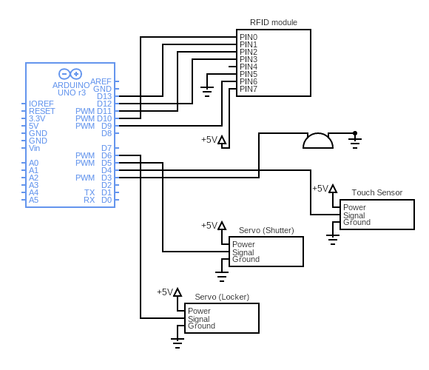

**Working of components**

**Arduino UNO Board:**

The user can get started by connecting the Uno to a computer with the USB cable or by powering it with an AC / DC adapter or battery. The Uno can be programmed with Arduino Software (Integrated Development Environment). Arduino Uno features 14 digital input /output pins (six of which can be used as PWM outputs), six analog inputs, and a16MHz quartz crystal. Uno also includes a USB connection, a power jack, an In-Circuit Serial Programming (ICSP) header, and a reset button. This Arduino MCU board contains everything the user needs to support the MCU.

**RFID reader module:**

The RFID module makes total 7 connections with Arduino, including the power and ground. The pins that are used here to connect the module are, D9, D10, D11, D12 and D13. A RFID reader stays powered on all the time and is normally powered from an external power source. So, when it is ON, the oscillator in it generates a signal with a desired frequency but as the signal strength will be very less (which may lead to fading off the signal if it is transmitted directly) it has to be amplified which can be done using an amplifier circuit, in order to propagate the signal to a longer distance we need to modulate the signal which is done by a modulator. With all these improvements the signal is now ready to be transmitted which can be done by an antenna which converts the electrical signal into an electromagnetic signal. The RFID reader signals are everywhere with its probity to detect a tag. When a RFID tag comes in the proximity of the RFID reader the tag detects the readers signal through a coil present in it which converts the received RF signal into an electrical signal. This converted signal alone is sufficient to power up the microchip present in the tag. Once the microchip gets powered up, its function is to send the data (unique ID) which it is stored in it. The same way the signal came in, it is sent out through the same coil into the air.

As discussed earlier the RFID reader also has a transceiver in it. When the signal comes back from the tag through the antenna of RFID reader it is fed to the demodulator and then decoded by a decoder where the original data can be obtained and then further processed by a microcontroller or a microprocessor to perform a specific task.

**Servo Motor:**

The servo motor is connected to the D8 pin of Arduino. A servo consists of a Motor (DC or AC), a potentiometer, gear assembly, and a controlling circuit. First of all, we use gear assembly to reduce RPM and to increase torque of the motor. Say at initial position of servo motor shaft, the position of the potentiometer knob is such that there is no electrical signal generated at the output port of the potentiometer. Now an electrical signal is given to another input terminal of the error detector amplifier. Now the difference between these two signals, one comes from the potentiometer and another comes from other sources, will be processed in a feedback mechanism and output will be provided in terms of error signal. This error signal acts as the input for motor and motor starts rotating. Now motor shaft is connected with the potentiometer and as the motor rotates so the potentiometer and it will generate a signal. So as the potentiometer’s angular position changes, its output feedback signal changes. After sometime the position of potentiometer reaches at a position that the output of potentiometer is same as external signal provided. At this condition, there will be no output signal from the amplifier to the motor input as there is no difference between external applied signal and the signal generated at potentiometer, and in this situation motor stops rotating.

**Capacitive touch sensor:**

The touch sensor is connected to the D4 pin of Arduino. Touch sensors work similar to a switch. When they are subjected to touch, pressure or force they get activated and acts as a closed switch. When the pressure or contact is removed, they act as an open switch. Capacitive touch sensor contains two parallel conductors with an insulator between them. These conductor plates act as a capacitor with a capacitance value C0. When these conductor plates come in contact with our fingers, our finger acts as a conductive object. Due to this, there will be an uncertain increase in the capacitance. A capacitance measuring circuit continuously measures the capacitance C0 of the sensor. When this circuit detects a change in capacitance it generates a signal. The resistive touch sensors calculate the pressure applied on the surface to sense the touch. These sensors contain two conductive films coated with indium tin oxide, which is a good conductor of electricity, separated by a very small distance. Across the surface of the films, a constant voltage is applied. When pressure is applied to the top film, it touches the bottom film. This generates a voltage drop which is detected by a controller circuit and signal is generated thereby detecting the touch.

**Buzzer:**

The buzzer is connected to D3 pin of Arduino. It consists of an outside case with two pins to attach it to power and ground. Inside is a piezo element, which consists of a central ceramic disc surrounded by a metal (often bronze) vibration disc. When current is applied to the buzzer it causes the ceramic disk to contract or expand. Changing the This then causes the surrounding disc to vibrate. That’s the sound that you hear. By changing the frequency of the buzzer, the speed of the vibration’s changes, which changes the pitch of the resulting sound.